Mastermind.

Project2

CSC- 5 – 46091 Intro C++

Jonathan Balisky

28 – July – 2015

Content

1.Introduction………………………………………….3-4  
Rule and Gameplay  
Thoughts after Program

2. Development………………………..………………4-5  
Approach Strategy

3. Research…………………………………………..…..5

Arrays

Parallel array

4. Variables list…………………………….………….…6

5. Topic Covered (Checklist)……………………………7

6. Libraries included……………………………………..7

7. Flowchart

8. Code

1. Introduction

**Rules and Gameplay**

This version of mastermind allows for two modes of gameplay easy or normal. In the easy mode the player has to guess a 3 digit pin, in normal a 4 digit pin. Regardless of which mode is selected the program will make each digit, of the pin, some number between 0-9. Each time after the player guesses, the program will tell the player how many digits are correct and are in the right place, and how many digits are the right digits, but not in the right place. The program will then display how many guess the player has left. If the player fails to guess the right pin in 9 tries, the program will display all the guesses that the player submitted, then sort and display them with and numerical sort and ask the player if they would like to try again.

**Thoughts after Program**

Next version of this game should have some sort of log of players’ best scores. The log would contain the players name, age, amount of games played, and the average of how many number of guesses it took to guess the answer. The game would start by asking who the player was and if no profile exist the program would ask the player to create one. The log would then be updated each and every time the player plays and the user can then check his ranking against other players before or after he/she plays.

2. Development

Approach Strategy

My main purpose was to create a Mastermind game more like the original. So I started with mastermind Jr. which is a simpler version of mastermind I came up with. Mastermind Jr. only had 3 digit pins so in the second version I decided to keep the 3 digit pin as and option for easy and added a 4 digit option for a normal mode.

Because most of the logic was already there from the Mastermind Jr. game I only had to add a few items to make it work. These items included more variables, a two dimensional dynamic array, a static array, a method for filling those arrays, pointers for the dynamic and a sorting method to sort the answers the that user gave.

3. Research

1. Double Pointer  
   The only way I know how to create a dynamic parallel array is to use a double pointer. Because of my need to use a dynamic array I implemented this code
2. Parallel arrays  
   In this project because I used arrays I then could use parallel arrays. I needed parallel arrays to check in a particular location (answer[0] compare to usrG[0]), was the same or not. Then after comparing on location I could then loop the next (answer[0] compare to usrG[1]).
3. Bubble sort  
   I thought it would be need to show the player’s answers then sort them numerically. Though it is not the most efficient sort I decided to implement the bubble sort due to the fact there would only be nine columns to sort max. The bubble sort check each digit of each row to the row after it. If the second row is smaller it is swapped with the first one. I used a Mark in place swap.
4. Dynamic Arrays

This program is designed to log all of the players’ answers for one round. Because the program allows the player can choose a 3 digit or a 4 digit pin, I wanted to implement a logging system that changes in size. So using a dynamic array, if the player chooses a four digit pin the array would have four columns, if three the array would have three columns.

4. Variables list

|  |  |  |  |
| --- | --- | --- | --- |
| **Type** | **Variable Name** | **Description** | **Line** |
| int | Level | How many digits the pin is | 33 |
|  | xs | right place counter | 40 |
|  | counter | How many times the player guessed | 44 |
|  | answer[SIZE] | Array for the answer | 35 |
|  | Indx | Location for the table | 265 |
| short | os | right number counter | 35 |
| char | ** table | Dynamic array for the players guesses | 43 |
| string | temp | Temporary place holder for the file | 36 |
|  | usrG | For the player to input guess | 39 |
| bool | match[SIZE] | check whether user digits matches answer | 34 |
|  | Swap | Check to see if swap was made | 264 |
| const int | SIZE | Size of arrays | 27 |
| ofstream | output |  | 37 |

5. Topic Covered (Checklist)

|  |  |  |  |
| --- | --- | --- | --- |
| Chapter | type | code | line |
| 2.1 Variables | int | int xs | 37 |
| 2.2 Input Output | Getline | getline(cin, temp); | 69 |
|  | cout | cout<<"Input your guess: "<<endl; | 74 |
|  | endl | cout<<endl; | 55 |
| 2.3 data types | Short | Short ox | 38 |
|  | bool | bool swap = false; | 264 |
|  | string | string usrG; | 39 |
| 2.4 condition | = | int level = 3; | 33 |
|  | == | while(isvalid(usrG) == false); | 97 |
|  | ++ | i++; | 124 |
| 2.5 style | comment | //variables | 31 |
| 3.1 boolean expression | != | if(usrG.length() != level){ | 189 |
|  | <, >, || | if (usrG[i] <48 || usrG[i] > 57){ | 195 |
| 3.2 multiway branches | if | if(usrG.length() != level){ | 189 |
|  | else | else{ | 193 |
|  | nested | do{ | 65 |
|  |  | if(input.is_open()){ | 45 |
|  |  | for(int j = 0; j<level;j++){ | 173 |
| 3.3 type of loop | for | for(int i = 0; i<9; i++){ | 172 |
|  | do-while | while(temp[0]!=49 && temp[0]!=50); | 70,71 |
| 4.2 predefined function | srand, time | srand(time(0)); | 41 |
|  | rand | answer[i] = rand()%10; | 159 |
| 4.3function prototypes | Int | int compare(int [], short&, string, … | 21 |
|  | Bool | bool isvalid(string, int); | 20 |
| 5.1 void function | void | void gssHst(string, int, char **, int); | 22 |
| 5.2 call-by-reference | & | int compare(int [], short&, string, bool … | 21 |
| 6.1 streams and basic | ofsream declare | ofstream output; | 37 |
|  | Ifstream declare | Ifstream input | 38 |
|  | Input | input.open("instructions.txt"); | 52 |
|  | Input.close | input.close(); | 58 |
|  | output | output.open("Answer.txt"); | 83 |
|  | close | output.close(); | 86 |
| 7.1 array | int array | Int answer[SIZE] | 34 |
|  | bool aray | Bool mathc[SIZE] | 35 |

6. Libraries included

* <cstdlib>
* <iostream>
* <ctime>
* <fstream>
* <string>

7. Pseudo code

Set time seed

Output instruction from file

Do

Ask user for easy or normal

Do

Call prepare function

Random answer and initialize other variables

Create table

Output the answer to file

Game start

do

Input guess number

Call isvalid to check validation

Call gssHst

Call compare function

Display Xs and Ox (result)

Guess -1

While guess>0 and guess answer is not correct

Call sort answers

Delete table

If x==level output win

Else output lose

Ask for another new game

While(Yes)

7. Flowchart

Main

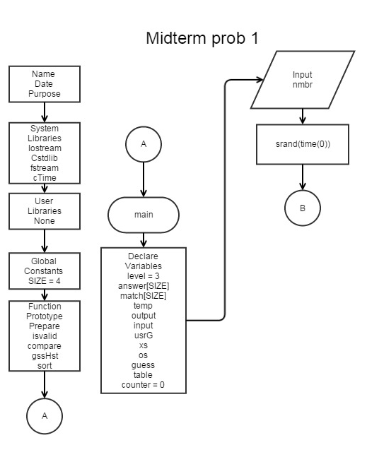

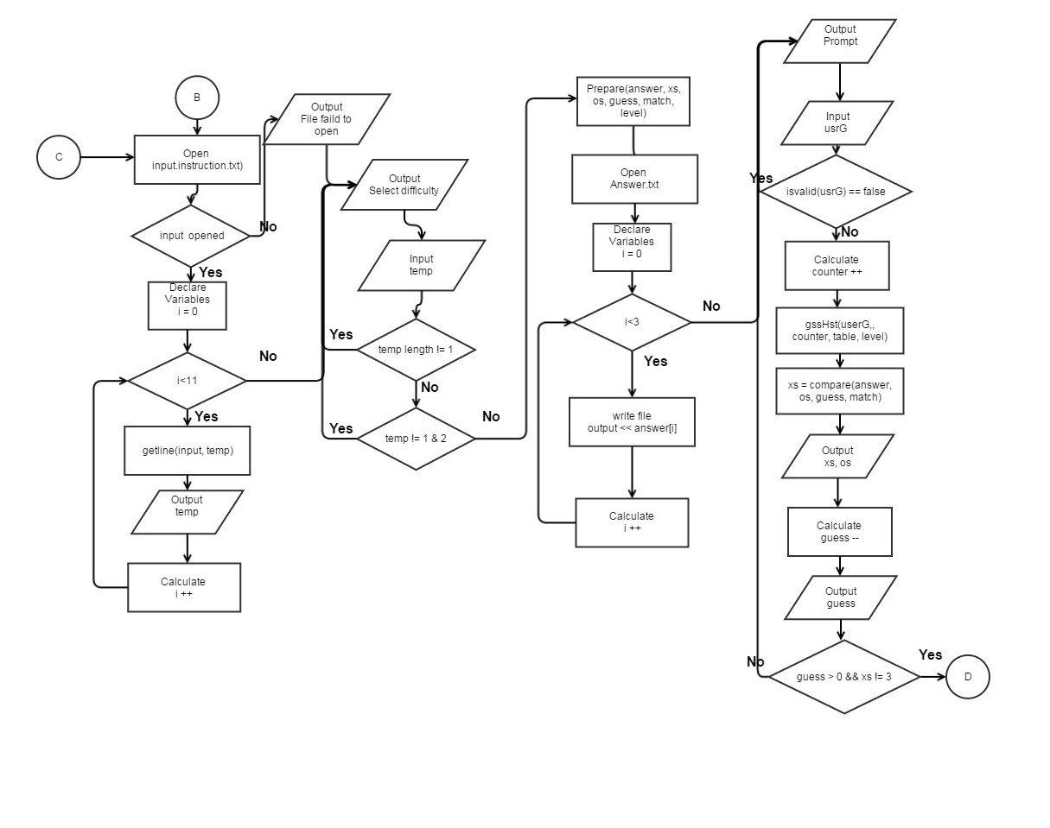 Main

Main

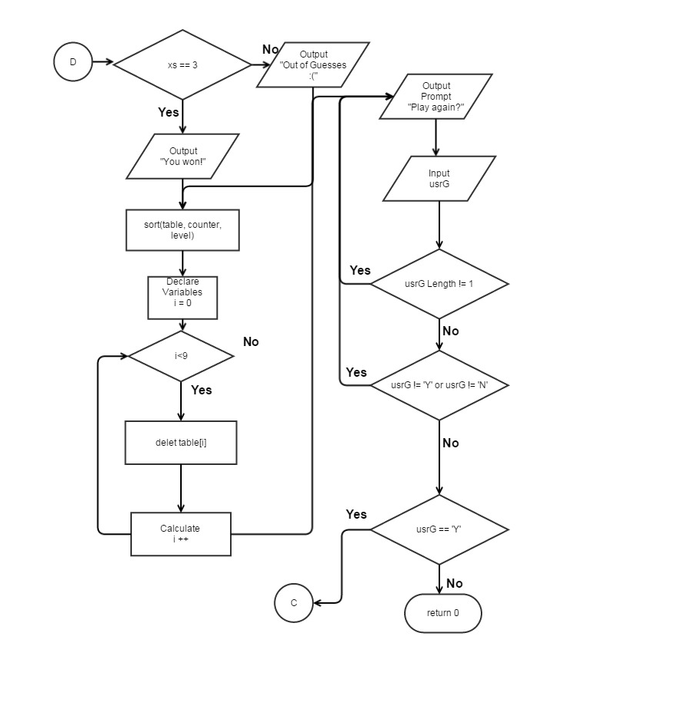

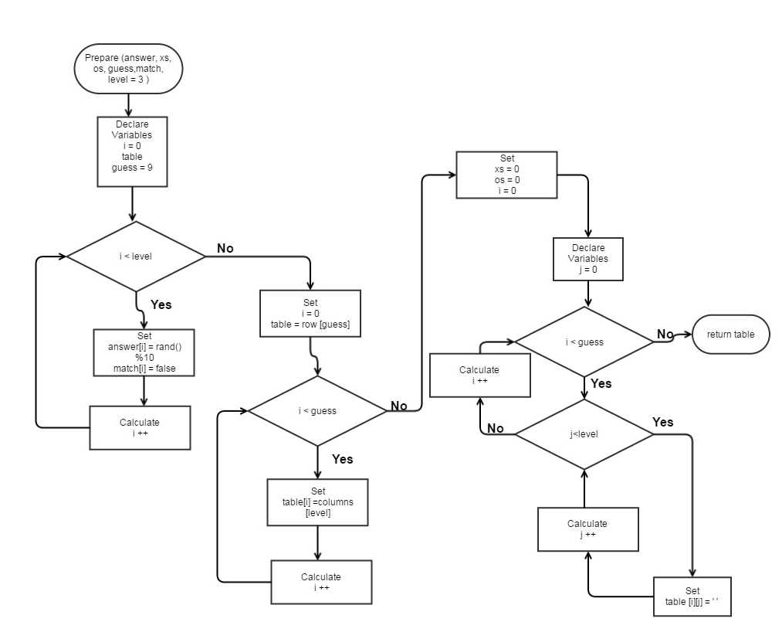Prepare

isValid

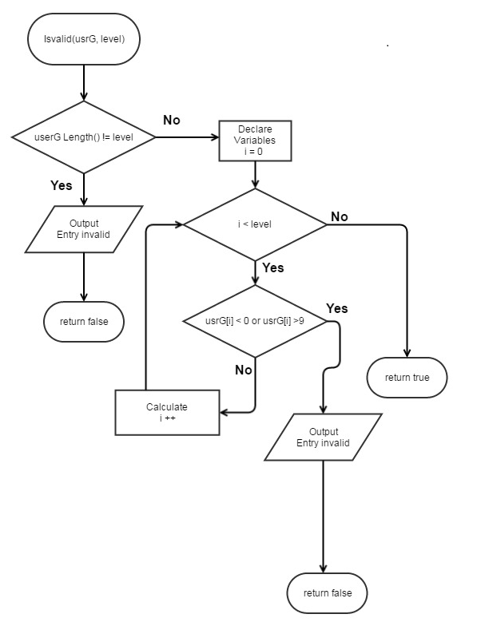

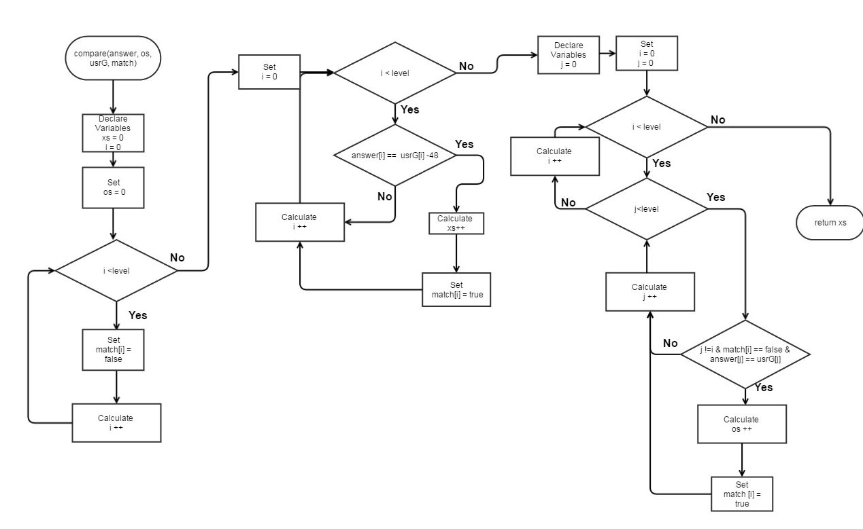Compare

gssHst

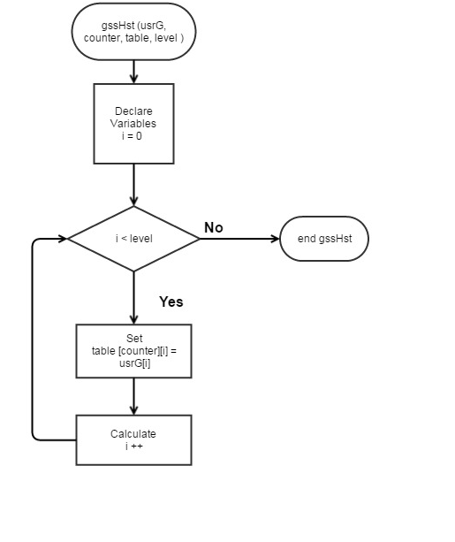

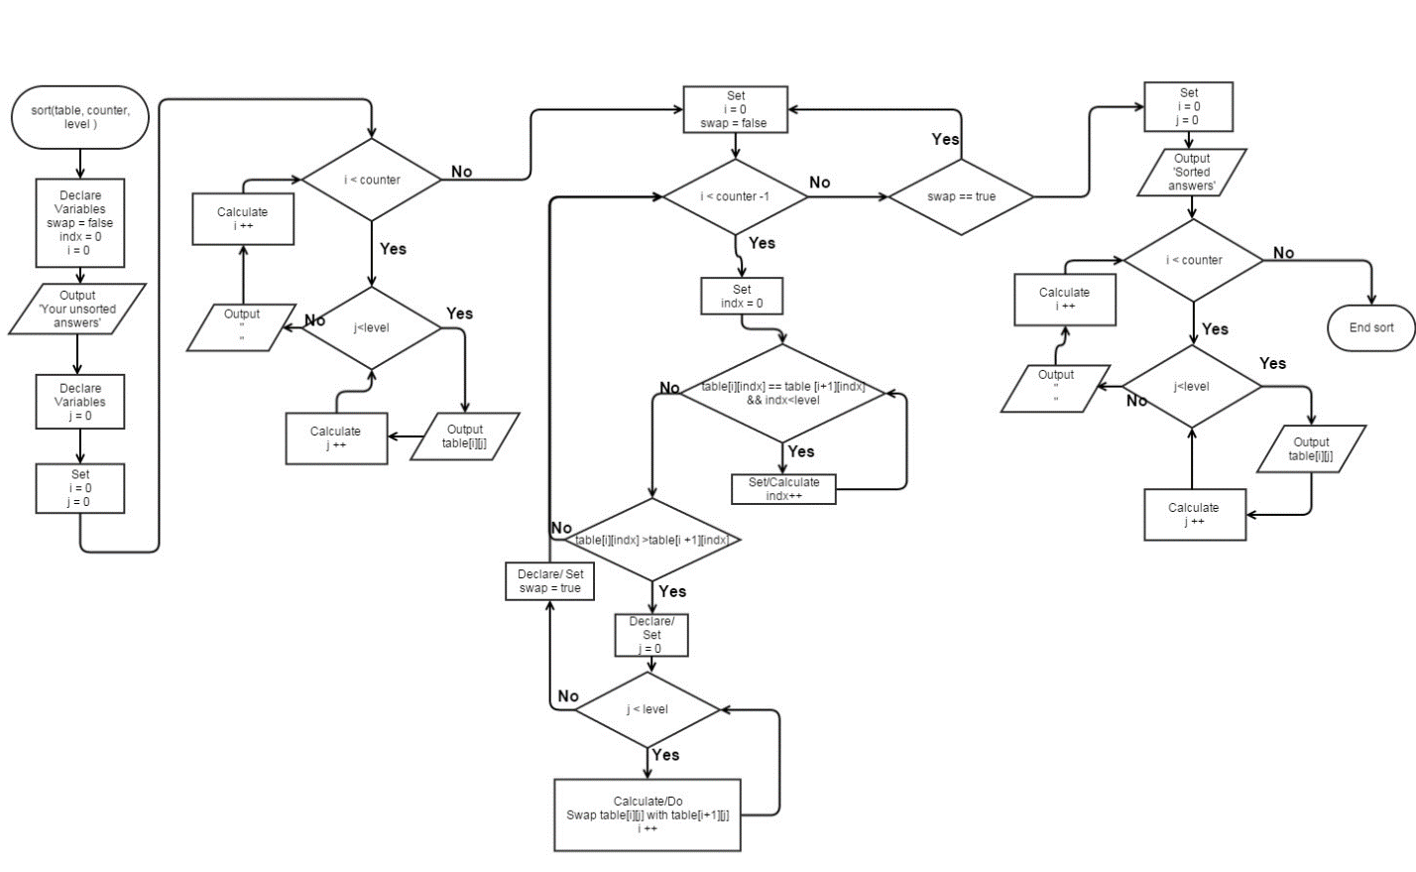Sort

8. Input, output (raw)

******************************************************************************

** **Mastermind **

** You have to guess numbers that are between 0-9 within 9 guesses!

** First select either easy or normal. easy = 3 numbers normal = 4

** First type in three or four numbers as your guess

** Then the game will show you the amount of Os and Xs you have for that guess.

** An O means that one of your numbers is correct but it is in the wrong position

** An X means that you have a number correct and in the right possition!

** So guess away! But remember you only have 9 guess. Run out of guesses and you lose.

** Do you have what it takes? Can you decode the sequence?

** We will soon find out...;)

What difficulty would you like to play? 1 for Easy or 2 for Hard: 2

Input your guess:

12314

Please enter 4 numbers.

Input your guess:

1231215

Please enter 4 numbers.

Input your guess:

dfe

Please enter 4 numbers.

Input your guess:

1234

x=0

o=3

Guesses left: 8

Input your guess:

9999

x=1

o=0

Guesses left: 7

Input your guess:

5689

x=0

o=1

Guesses left: 6

Input your guess:

342

Please enter 4 numbers.

Input your guess:

2315

x=2

o=1

Guesses left: 5

Input your guess:

2912

x=4

o=0

Guesses left: 4

Congrats you won!

Unsorted answers from you!!

1234

9999

5689

2315

2912

Sorted answers via bubble sorts !!

1234

2315

2912

5689

9999

Play again Y/N?

1

Play again Y/N?

4

Play again Y/N?

s

Play again Y/N?

Y

******************************************************************************

** **Mastermind **

** You have to guess numbers that are between 0-9 within 9 guesses

** First select either easy or normal. easy = 3 numbers normal = 4

** First type in three or four numbers as your guess

** Then the game will show you the amount of Os and Xs you have for that guess.

** An O means that one of your numbers is correct but it is in the wrong position

** An X means that you have a number correct and in the right possition!

** So guess away! But remember you only have 9 guess. Run out of guesses and you lose.

** Do you have what it takes? Can you decode the sequence?

** We will soon find out...;)

What difficulty would you like to play? 1 for Easy or 2 for Hard: 1

Input your guess:

123

x=0

o=0

Guesses left: 8

Input your guess:

123

x=0

o=0

Guesses left: 7

Input your guess:

123

x=0

o=0

Guesses left: 6

Input your guess:

1234

Please enter 3 numbers.

Input your guess:

543

x=0

o=0

Guesses left: 5

Input your guess:

674

x=1

o=1

Guesses left: 4

Input your guess:

865

x=1

o=0

Guesses left: 3

Input your guess:

456

x=0

o=0

Guesses left: 2

Input your guess:

345

x=0

o=0

Guesses left: 1

Input your guess:

86

Please enter 3 numbers.

Input your guess:

567

x=1

o=1

Guesses left: 0

Sorry but you ran out of guesses. :(

Unsorted answers from you!!

123

123

123

543

674

865

456

345

567

Sorted answers via bubble sorts !!

123

123

123

345

456

543

567

674

865

Play again Y/N?

N

See you again next time!

RUN SUCCESSFUL (total time: 1m 21s)

9. Code

/*

File: Game.cpp

Author: Jonathan Balisky

Created on July 25, 2015, 9:18 pM

Purpose: Mastermind jr.

*/

//Libraries

#include <iostream>

#include <string>

#include <cstdlib>

#include <fstream>

#include <ctime>

using namespace std;

char ** prepare(int [], int&, short&, int&, bool[], int);

bool isvalid(string, int);

int compare(int [], short&, string, bool[], int);

void gssHst(string, int, char **, int);

void sort(char **, int, int);

//Global

const int SIZE = 4;

int main(int argc, char** argv) {

//Variables

int level = 3; //Difficulty of game

int answer[SIZE]; //number of pin

bool match[SIZE]; //Which numbers are matched

string temp; //For the file output

ofstream output; //

ifstream input; //inputting to the file

string usrG; //The users guess or input

int xs; //How many x's

short os; //How many o'x

int guess; //How many guess the user had guessed

char **table; //Table of the user guesses

int counter = 0; //Row counter for table

srand(time(0)); //setting time seed

do{

counter = 0;

// cout<<"Call prepare."<<endl;//For diagonostics

input.open("instructions.txt");

if(input.is_open()){

for (int i = 0; i<11; i++){

getline(input,temp); //Change instructions

cout<<temp;

}

input.close();

}

else{

cout<<"Instructions failed to open"<<endl;

}

cout<<endl;

do{

do{

cout<<"What difficulty would you like to play? 1 for Easy or 2 for Hard: ";

getline(cin, temp);

}while(temp.length() != 1); // User did not enter 1 digit

}while(temp[0]!=49 && temp[0]!=50);// User did not enter 1 or 2

if (temp[0] == 49){ //Level is easy

level = 3;

}

else{ //User selected hard level

level = 4;

}

table = prepare(answer, xs, os, guess, match, level); //Initialize

// cout<<"Call prepare."<<endl;//For diagonostics

output.open("Answer.txt");

for (int i = 0; i<level; i++){

output<<answer[i];

}

output.close();

// for(int i=0;i<3;i++){

//cout<<answer[i]; //For diagonostics

// }

do{

do {

cout<<"Input your guess: "<<endl; //User enter guess

getline(cin,usrG);

//cin.ignore();

}while(isvalid(usrG, level) == false); //Loop until user enters valid answer

gssHst(usrG, counter, table, level);

counter++;//gssHst Ran

xs=compare(answer, os, usrG, match, level);

cout<<"x="<<xs<<endl; //Right numbers in right space

cout<<"o="<<os<<endl; //How many Correct number but in the incorrect space

guess--;

cout<<"Guesses left: "<<guess<<endl;

}while(guess > 0 && xs != level);// User out of guess or has guess correctly

if ( xs == level){ //user won

cout<<"Congrats you won!"<<endl;

}

else{ //user lost

cout<<"Sorry but you ran out of guesses. :( "<<endl;

}

sort(table, counter, level);

for (int i = 0; i <9; i++){

delete table[i];

}

delete[] table;

do{ //Checking for an input of Y or N

do{ //Checking for input over 1 char

cout<<"Play again Y/N?"<<endl;

getline(cin,usrG);

}while(usrG.length() != 1);

}while(usrG[0]!=89 && usrG[0]!=78);

//}while(usrG[0] > 'Y' || usrG < 'N' || (usrG[0]>'N' && usrG[0]<'Y'));

}while(usrG[0]=='Y' );

cout<<"See you again next time!"<<endl;

return 0;

}

/***************************************Prepare**************************************************

* Purpose: Initializing values for the game.

* Input: answer, xs, os, guess, match, level

* Output:

* table

***********************************************************************************************/

char ** prepare (int answer[], int &xs, short &os, int &guess, bool match[], int level = 3){

char **table;

guess = 9;

for (int i = 0; i<level; i++){

answer[i] = rand()%10; //creating answer from 0-9

match[i] = false; //Set all to false

//cout<<"answer = "<<answer[i]; //For diagonostics

}

table = new char *[guess]; //Creating 2 d dynamic array

for (int i = 0; i<guess; i++){ //

table[i] = new char[level];

}

// cout<<endl;

xs = 0;

os = 0;

for(int i = 0; i<guess; i++){//Filling the array with empty spaces

for(int j = 0; j<level;j++){

table[i][j]= ' ';

}

}

return table;

}

/***************************************isvalid**************************************************

* Purpose: To check whether or not the user entered 3 numbers

* Input: usrG, level

* Output: True or false

***********************************************************************************************/

bool isvalid(string usrG, int level){

// cout<<"Call isvalid."<<endl; //For diagonostics

if(usrG.length() != level){

cout<<"Please enter "<<level<<" numbers."<<endl;

return false;

}

else{

for(int i = 0; i < level; i++){

if (usrG[i] <48 || usrG[i] > 57){

cout<<"Number not entered"<<endl;

return false;

}

}

// cout<<"number valid"<<endl;//For diagonostics

return true;

}

}

/***************************************Compare**************************************************

* Purpose: To compare the user's guess with the answer and return how many

* were correct or incorrect.

* Input: answer, os, usrG, match, level

* Output:xs

***********************************************************************************************/

int compare(int answer[], short &os, string usrG, bool match[], int level){

int xs = 0;

os = 0;

for(int i = 0; i<level; i++){

match[i] = false; //int all values to zero again

}

//Checking for correct numbers in the right position

for(int i = 0; i<level; i++){

if(answer[i] == (usrG[i]-48)){ //subtracting 48 makes it an integer

xs++;

match[i] = true;

}

}

//Checking for os

for(int i = 0; i<level; i++){ //i is position of answer

for(int j = 0; j<level; j++){ //j is position of usrG(user guess)

if(j !=i && match[j] == false && answer[i] == usrG[j]-48){

//cout<<"increased o"<<endl; //For diagonostics

os++;

match[i] = true;

}

}

}

return xs;

}

/***************************************gssHst**************************************************

* Purpose: To keep a record of the the user's guesses

* Input: usrG, counter, table

* Output:none

***********************************************************************************************/

void gssHst(string usrG, int counter, char **table, int level){

for(int i = 0; i<level;i++){

table[counter][i]= usrG[i];

}

// cout<<"\n"; //For Diagnositics

// for(int i=0;i<9;i++){

// for(int j=0;j<level;j++){

// cout<<table[i][j];

// }

// cout<<"\n";

// }

// cout<<"\n\n\n\n";

}

/***************************************Sort***************************************************

* Purpose: To Sort all the user guesses to show I can do it...so HA! Using a bubble sort

* Input: table, counter, level

* Output:none

***********************************************************************************************/

void sort(char **table, int counter, int level){

bool swap = false;//For the bubble swap function

int indx = 0; //Second index location for table

cout<<"Unsorted answers from you!!"<<endl;

for(int i = 0;i<counter; i++){

for(int j = 0;j<level; j++){

cout<<table[i][j];

}

cout<<endl;

}

do{

swap = false;

for(int i = 0; i<counter-1; i++){ //counter -1 because bubble swap is always columns - 1

indx = 0;

while(table[i][indx]==table[i+1][indx] && indx<level)indx++;//Checking to see if current

//index is equal then going to next location if they

//are equal.

if ( table[i][indx]>table[i+1][indx]){ //If that row and col. not equal

//then check if first is larger if it is then swap all numbers

cout<<"i>i+1"<<endl;

for(int j = 0; j <level; j++){ //Swapping each 2 rows and their respective columns until all the rows are swapped

table [i][j] = table [i][j]^table[i+1][j]; //in place swap. to hopefully make Dr lehr happy so he give me extra credit

table [i+1][j] = table [i][j]^table[i+1][j];

table [i][j] = table [i][j]^table[i+1][j];

}

swap = true;

}

}

}while(swap == true);

cout<<"Sorted answers via bubble sorts !!"<<endl;

for(int i = 0;i<counter; i++){

for(int j = 0;j<level; j++){

cout<<table[i][j];

}

cout<<endl;

}

}